Making a Pinwheel

Subject:  Related Subjects: | Grade Level(s):  Length of Lesson: | Type: Inquiry / Design / Project  Keywords:

Lesson Overview
Use this section to describe at a high level what the lesson is. Should be no more than 3-4 lines.

Lesson Focus
What is the central question or phenomenon being investigated? What problem are they trying to solve?

Lesson Objective(s) | By the end of this lesson, students will…  - Learn the concepts of attraction, repulsion, friction, polarity, and charge.

Lesson Timing

5 minutes | Introduce the Lesson
30 minutes | ...

Materials | - Construction paper  - Scissors  - Ruler  - Pencil or straw  - Stickpin or paper clip or push pin
Instructor Prep | - Step 1
Related Resources | - List related lessons/ppts etc available from USC or outside, trusted orgs

Lesson Plan

Introduction

Last week students learned about drag and how that played a role in the helicopter’s decent. This week we will go more in depth about how the wings actually catch the wind by making pinwheels. We will discuss how the wind propels and mention how that goes into wind power.
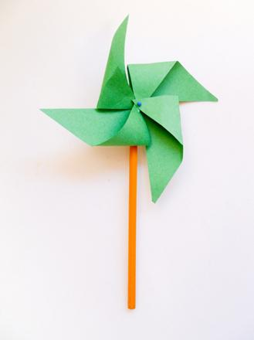

Procedure

- Invite your child to use the ruler to measure a 6" x 6" inch square. They can use scissors to cut out the square for making the pinwheel.
- Now they can use the ruler to draw an X from corner to corner on the square dividing it into four triangles.
- Offer the scissors and have them cut from each corner along the line until they just about reach the center of the square – but not cutting all the way through! When finished, they’ll have four cuts moving diagonally towards the middle.
- To create the pinwheel, invite your child to begin folding in one corner of each "triangle" to the middle of the square. She can hold the pieces together and then secure them by pushing a stickpin through the middle.
- Now she can secure the pinwheel to the eraser of a pencil and take her finished pinwheel outside to enjoy!

Wrap-up
End the lesson with some final discussions about what students designed/discovered. Connect their activity back to the focus question/problem, real world examples, and STEM careers.

Also include notes about any special cleanup considerations

Lesson Background for Teachers

Suggested Real-World STEM Connections
- List possible related Role Models in STEM (with details and links to more reading). Give suggestions for examples of scientists/engineers who are from underrepresented groups in STEM in related careers.
- List related real-world engineering problems and examples

Lesson Variations and Options
Include descriptions of alternative methods or ways to present things.

Explanation
Describe the background concepts and explanations behind the lesson. This can be more in depth than a teacher/instructor would actually share with students.

Key Concepts and Vocabulary
- Word 1: Grade Appropriate Definition
- Word 2: Grade Appropriate Definition

Safety Notes
- Safety instruction

